# Using the Visual Studio Android Emulator

Sometime the Visual Studio emulator does not connect to the ADB server.

In the case where the emulator starts but is not connected to the ADB server the app is not installed on the device and the deployment process is stuck.

Follow the steps

1. On the VS emulator click on the arrow to open up additional tools, click on the Network tab

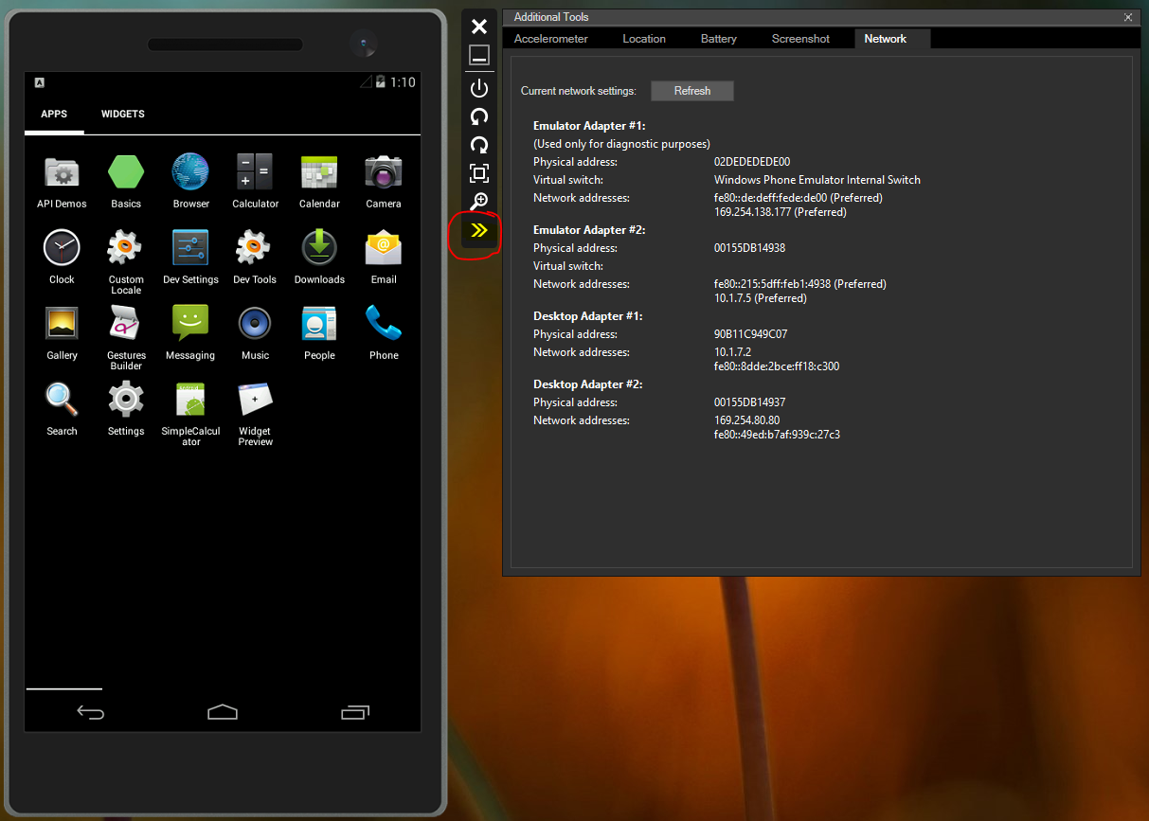

1. Make a note of the IP address

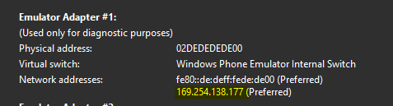

Go to Tools -> Options

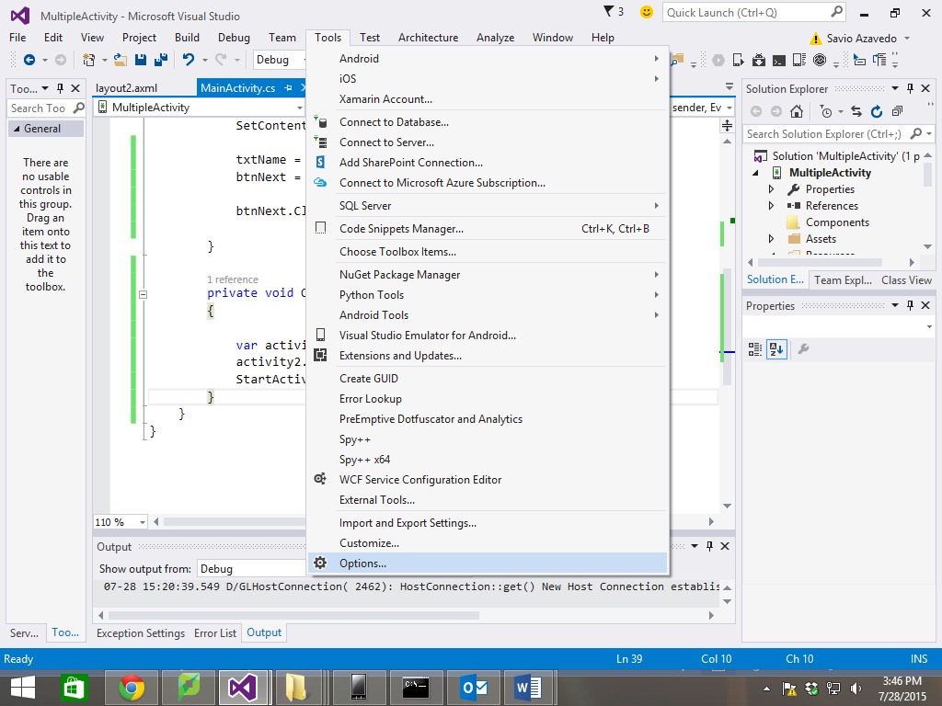

Find your android SDK location

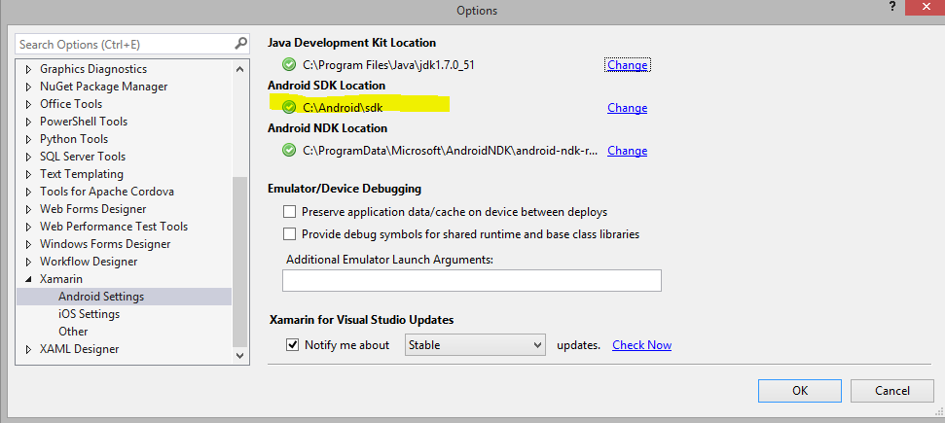

1. Go to your android- sdk/ platform tools folder, copy it and paste it in your command prompt



And type the command adb connect <ip_address>:5555

You should get a message



Now when you go adb devices



You should see your device connected.